LSA CA Summer School Report 2019 by Eleanor Anderton
JSST CC & AH Summer School: Making Classics even more fun (if that’s possible!)
The first thing any budding Classicist will notice when they enter Repton school and become introduced into the summer school environment, is how passionate and excited everyone is about the ancient world. This is a running theme that continues throughout the five-day excursion into the world of the ancients, and it is something that makes the summer school particularly unique. More importantly however, it is also the reason why I would personally push anyone and everyone thinking about studying Classics or ancient history further at A level or university, or even those just with an interest in the study of past civilisations, to apply and attend.
One of the things that I particularly liked about the summer school was the intensity of it. Due to the fact that the course is only five days long, the teachers make sure that they fit in as much of the ancient world as they can, so that the students can get the most out of their experiences. Therefore, the structure of the day is as follows: five one-hour sessions (of which you choose from a wide range of topics), one compulsory group activity session and then rehearsals for the theatrical performance at the end of the week. Obviously, they do give you time to eat also! This packed day was perfect for me, as it meant that you were constantly meeting new people and learning new things. This is thoroughly encouraged at the summer school, and is reflected in the variety of teaching topics available; from the rise and fall of the Roman Empire to Sanskrit. Thus, the large number of topics available, combined with the fact that you are being taught for five hours a day, meant that within the space of a week, your knowledge of the ancient world, outside of the GCSE and A level syllabus, expands rapidly. This puts you in a great position for future personal statement writing.
Of course, though, the taught sessions would be nothing without the exceptional teachers preparing and delivering them. What I liked most of all was the differences between each teacher I had, for example, some of my taught sessions were delivered in a relaxed, discussion-based environment where we all sat in a circle and debated our thoughts and opinions on topics. Other sessions I experienced were taught in a more lecture-style environment, where questions could be asked and discussed at any point and where I would make reams and reams of detailed notes! And so, the differences in the teaching methods made the sessions themselves livelier, as the variation made you excited to move on from one amazing session into another equally amazing session. Also, the individualism of each session really helped to reflect the individual passion of the teachers for their subject.
Another aspect of the summer school that understandably can seem daunting, is the rehearsing and subsequent performing of an ancient comedy or tragedy at the end of the week. Where there were a number of people who naturally relaxed into the idea of taking on a role and performing, most were the exact opposite. However, the whole experience quickly, whether you like drama or not, becomes incredibly fun, because of the fact that you are not forced into any aspect of the play. If the thought of performing makes you feel sick, you have the opportunity to help out with costume or props. However, if you love the stage and performing, you are given the opportunity to dramatically throw yourself into your role, as making a fool out of yourself is simply not an option when you are surrounded by your friends.
Finally, the reason why I am so glad to have had attended the summer school, is because of the people I met whilst I was there. Despite the fact that Repton is located in the midlands, you meet such a variety of people from all around the UK, and even some from as far afield as the US. I myself attended the summer school without any friends with me, which meant that I had the amazing opportunity to make new lifelong friends, whom I am still in contact with now and hope to be in the future! Furthermore, the amazing thing about meeting these people at a Classics and ancient history summer school, is that you already have so much in common due to your love of the ancient world! This makes meeting new people and making new connections incredibly easy, which is seen in the fact that a number of those in attendance this year, had come back from previous years. This in itself shows how incredibly attached you get to a group of people, and the ancient world in itself, in the space of a few days.
Therefore, I would wholeheartedly and without a doubt encourage anyone with an interest in Classics or ancient history to apply to this summer school, as I can guarantee you will not regret it!
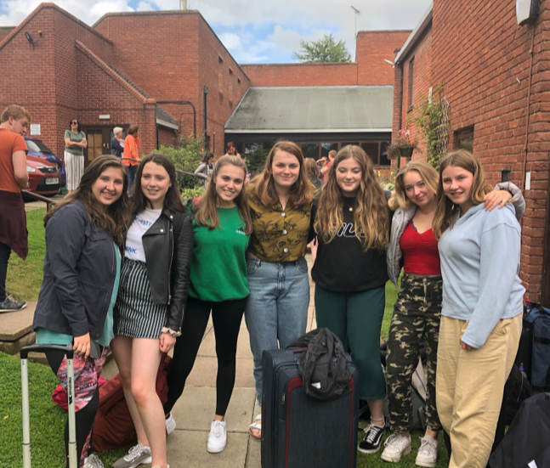
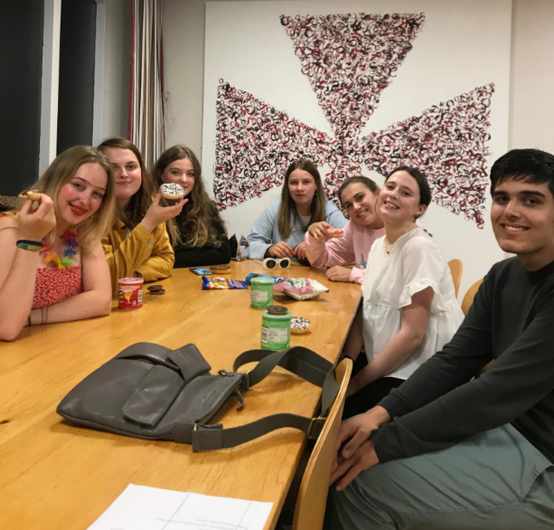
The final goodbye before leaving.
The party on the last night, after the theatrical performances.
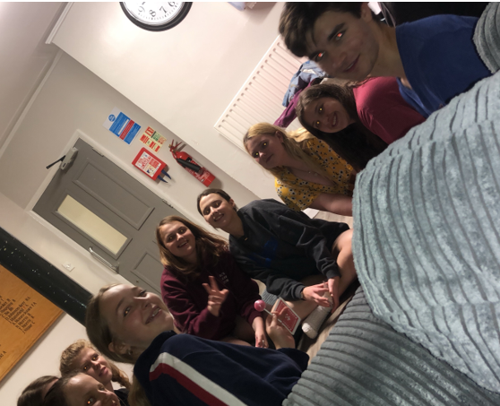
Free time in the common room, playing cards after the rehearsals for the comedy and tragedy.

