Repton Summer School 2017 was one of the best summer experiences I’ve ever had. I met great people, was taught by great people, and even had the pleasure of feeling like a great person among all the bright minds, encouraged to pursue the likewise passion we all share for classics.

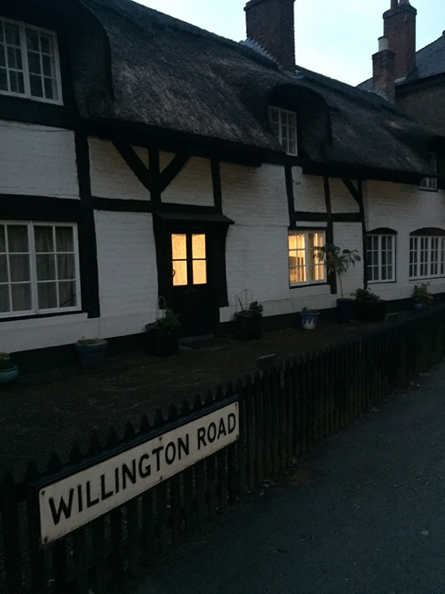
I’ll start with the facilities. My dorm room at Repton was a single and had enough space as such, with a lovely view of the back courtyard and a couple of the many fields on Repton property. Everything was kept very clean by the nice matrons who came in everyday to change the bin bag as needed, in my dorm as well as the bathrooms. The hall we ate in held us all no problem and soon enough people stopped going to random tables and awkwardly making conversation in hopes of getting on with classes as groups of friends formed and molded into one big group. Meals were provided three times a day; breakfast, lunch, and dinner; and the food was very accommodating to needs (I’m a vegetarian and allergic to mushrooms and the lunch ladies were kind enough to make me something different on the first day since the vegetarian options had mushroom). If anyone wanted snacks or whatnot, there was a Spar two minutes walk down the road. The classrooms were just as tidy as everywhere else, albeit very hot, but with the number of us it was easy to come to enjoy classes and get one-on-one conversations with your teacher. Across the road was a beautiful church with a crypt dating back to the eighth century.
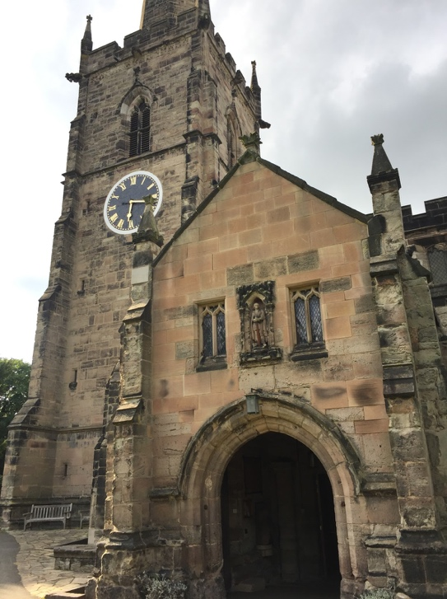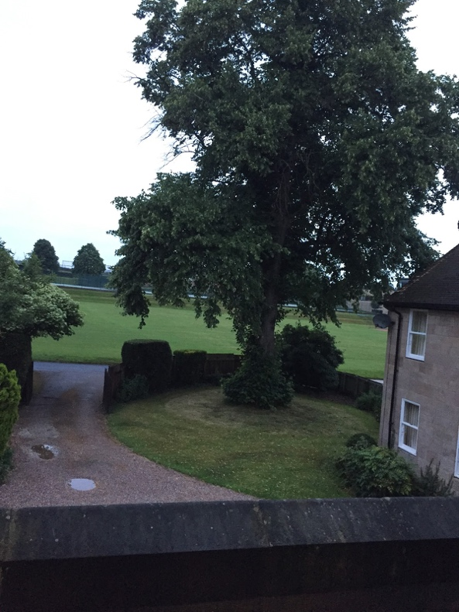

The schedule itself was very well planned out. You could have up to six classes a day though it was recommended to drop one and have a break in the day. The classes I chose were Minoans and Mycenaeans, Introduction to Latin, Barbarians in the Ancient World, then I had a break fourth period, then I ended the learning portion of the day with Socrates and Philosophy (incredibly entertaining), and finally Myth in the Ancient World. I’ll talk about these in just a second. Alongside classes, the mealtimes fit between these to keep us going for a long, long day. Breakfast was just before the first class, then lunch started at 1.15 and ended at 3, the longest lunch JSST has had yet, a response to last year’s complaints for not having enough time. The extra time let us relax, hang out with friends, do any work from classes, or just read. There was a lot of us who liked to sit under the tree shade and open a book. Dinner was at 7PM and the last class ended at 5. Of course, that two hours could have been free time, but there were some fantastic Facts at 5.5, or lectures from the teachers at 5.30, on things like how Google and oracles correlate or Shakespeare and Classics or taking classics to university. They were all very insightful and for the most part, everyone gave up the free time to attend, which was really moving to see. Imagine 30-40 people trying to pile into a classroom for Google and oracles! After dinner, it was compulsory to take part in one of two plays, a Greek tragedy (Aeschylus’ The Suppliant Maidens) or a Greek comedy (Aristophanes’ The Birds), whether it be making costumes and props or actually acting in the play. I performed in The Birds and played Euelpides, both a hilarious and exhilarating experience to rehearse and perform in four days. We had scripts on the night but it was still done quite off the head, and there were many celebratory photos.
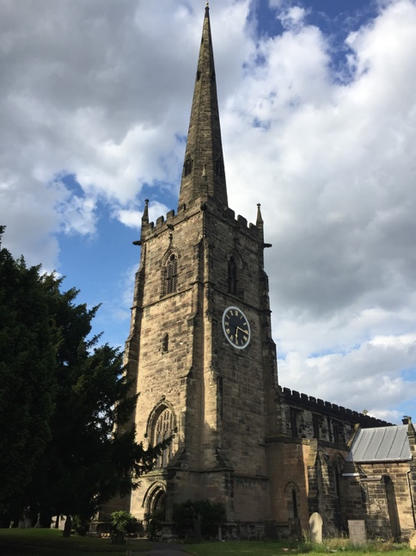
Classes were the focus of the summer school that tied it all up. I learned basic Latin, a neat history of the Minoans and Mycenaeans (including a little Linear B), followed by the Persians and the Amazons and Barbarians, compared ancient myths to modern, but my favorite class was philosophy. We spent three of the four days going back and forth as Socrates would have over the meaning of virtue, twisting our heads up to conclude that we can’t comprehend it, as it varies from person to person. The second day we read a passage from Menos by Plato and only conversed about the very first line. The fourth day we talked about Protagoras and Socrates and their meaning of the art of politics, and how it wound up back at virtue. I had never been in a philosophical debate and it was absolutely wonderful to sit in one group and hear each other’s thoughts without prejudice, only minding what they said and turning it over until it gave fruit. It was astounding to be in a classroom with so many like minded people all truly interested in what was going on, not waiting for the OK to go to the next lesson. We all wanted it to go on just little longer, to say just a few more words.

The tutors themselves were wonderful. The second lesson of Latin left me upside down; I have dyslexia and don’t recognize patterns very well so I considered I may be wasting my time trying to get something my brain wouldn’t let me, but I was determined to get through it. I went to Kate, the teacher, and asked her to help me a little more, so she sat down with me for fifteen or so minutes and walked me through it until I understood, and after that I was much more confident. Dan, the course director, gave me a big hug during the afterparty of the plays after I thanked him for the fantastic time and wished me the best of luck with everything, as well as that I come back next year.

And I have to say, given the chance, I wouldn’t hesitate to. The JSST Summer School has given me an amazing summer with like minded people, great learning, and a lovely place to stay. It was truly something that benefitted me as a writer with all that I gained in terms of knowledge of the ancient world and in experience itself, and I am forever grateful for the bursaries I received to make it happen. 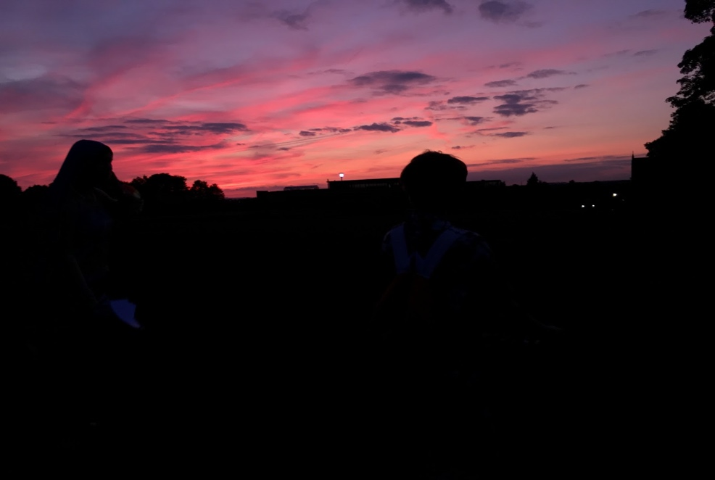

It also taught me something very, very important as a classicist. Classics is not dead. There are still so many people in love with learning about the ancient world, many of them young adults such as myself. I look forward to seeing where all those wonderful people I met at the summer school will take classics in the years to come.

